|  |  |  |
| --- | --- | --- |
| **External Document** | January 29  2015 | |
|  | | Portfolio website BO LIU 300756885 https://github.com/alexliubj/portfolio |

Table of Contents

1. Brief Description 2

2. Nav bar 2

3. Typography 3

4. SiteMap 4

5. Wireframes 5

6. Branding 6

# Brief Description

This website contains 6 major pages.

* Home page shows my featured work, personal tagline, site map, my development skill and footer as well.
* About me shows some brief introduction of me, my relevant work experience and my education background.
* Projects showing my recent projects.
* Services showing the three major services I can provide.
* My Github a screenshot of my Github home page and a button which can redirect to my Github homepage.
* Contact me showing my home address and a form provides the viewer who wants to contact me.

# Nav bar

Nav bar for home (non-mobile)



Nav bar for about me



Nav bar for projects



Nav bar for home (mobile)

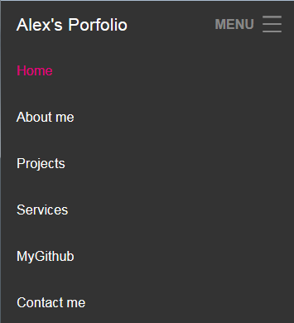

Nav bar for about me (mobile)

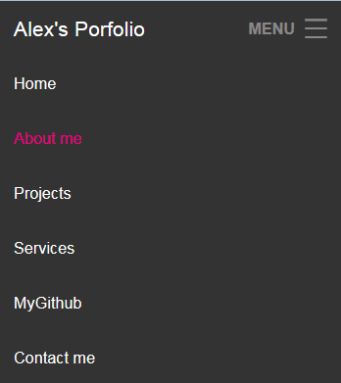

Nav bar for projects (mobile)

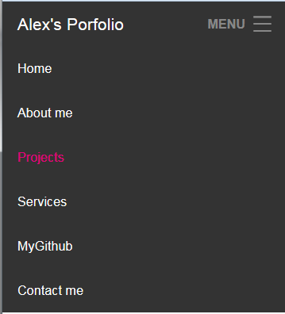

# Typography

C:\Users\AlexLiu\Desktop\2.PNG

C:\Users\AlexLiu\Desktop\3.PNG

C:\Users\AlexLiu\Desktop\4.PNG

C:\Users\AlexLiu\Desktop\6.PNG

C:\Users\AlexLiu\Desktop\7.PNG

C:\Users\AlexLiu\Desktop\8.PNG

C:\Users\AlexLiu\Desktop\9.PNG

C:\Users\AlexLiu\Desktop\1.PNG

# SiteMap

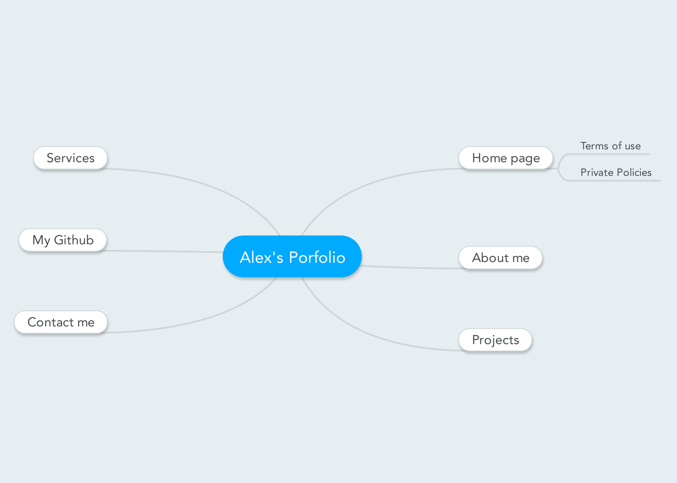

# Wireframes

Home page example: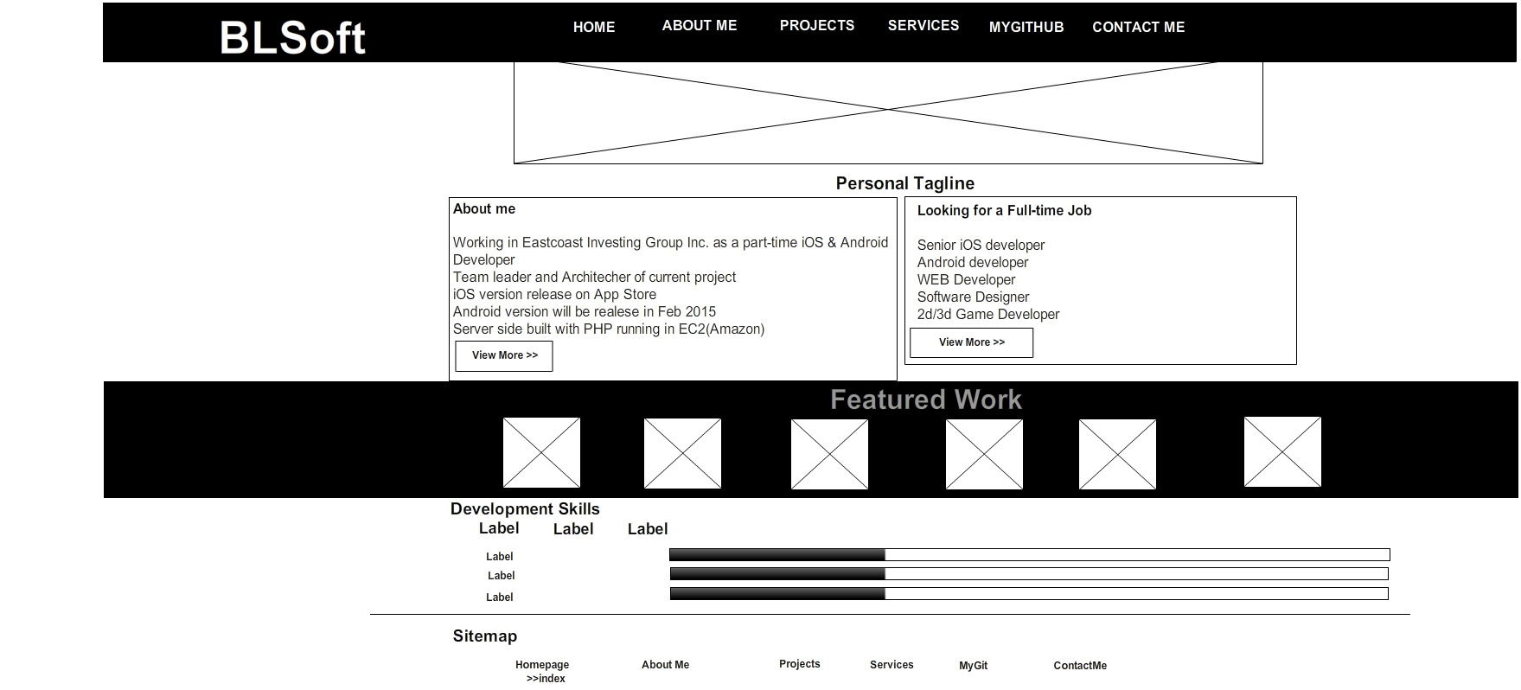

Projects:

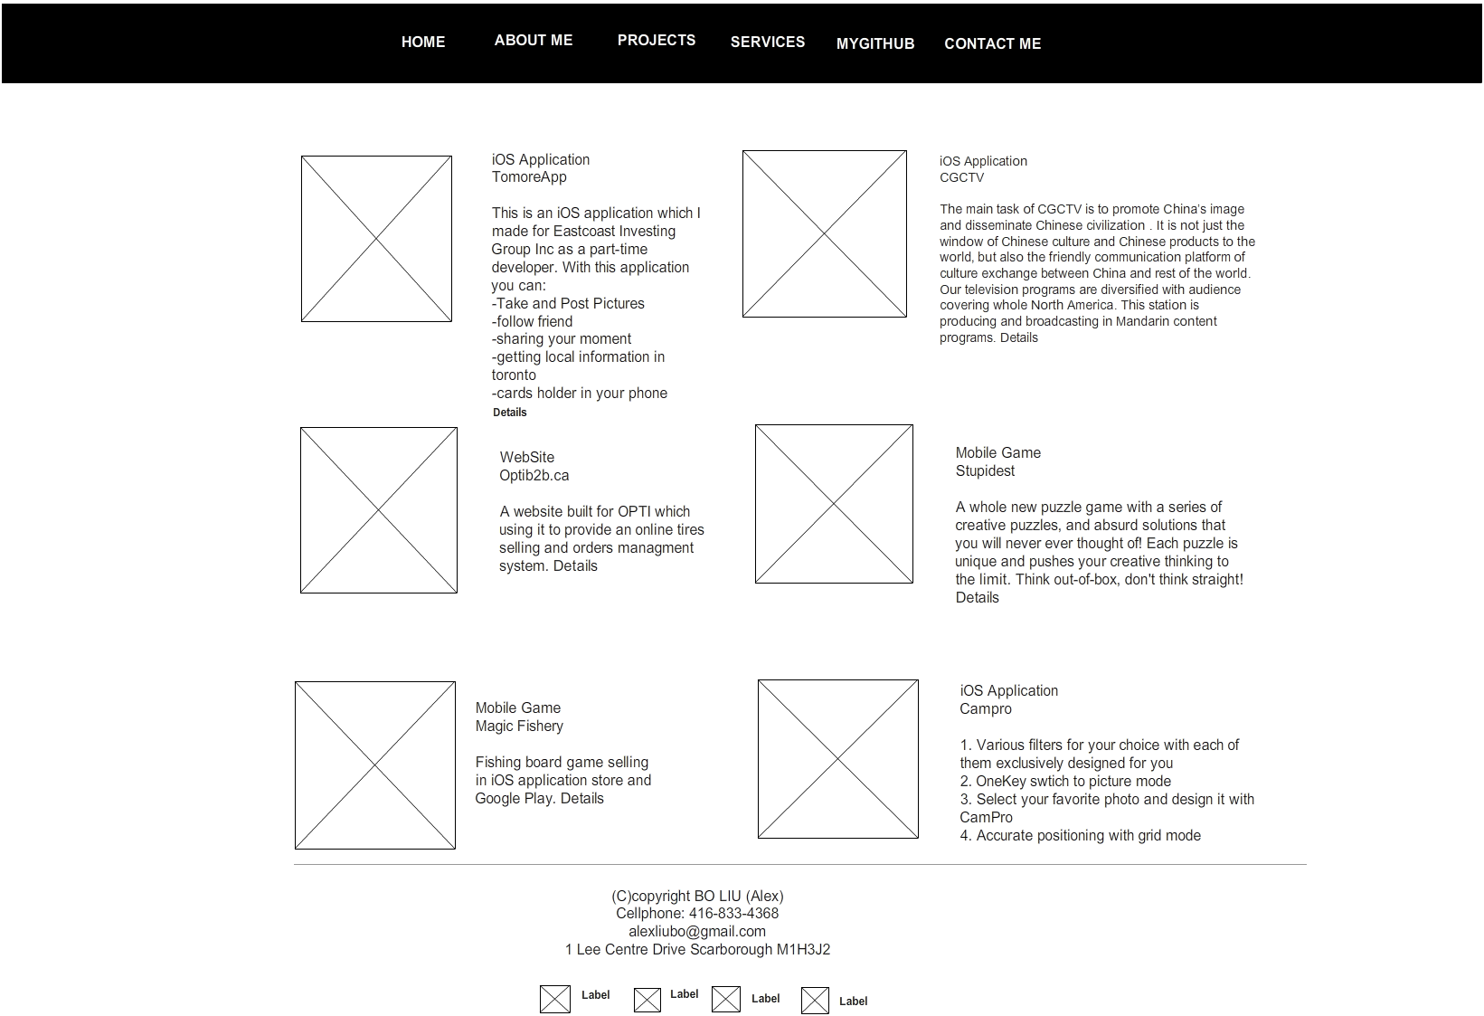

About me:

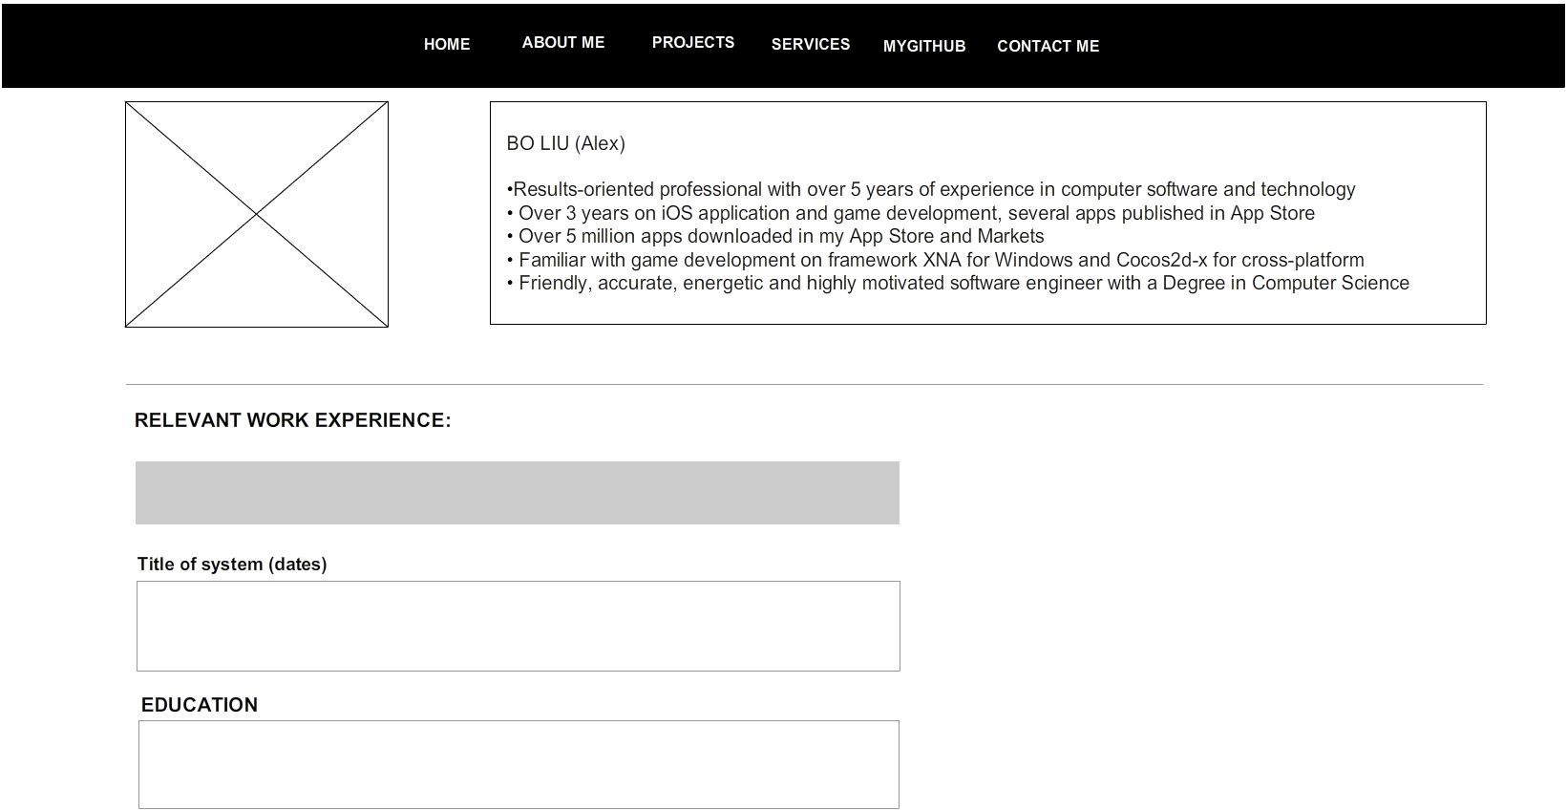

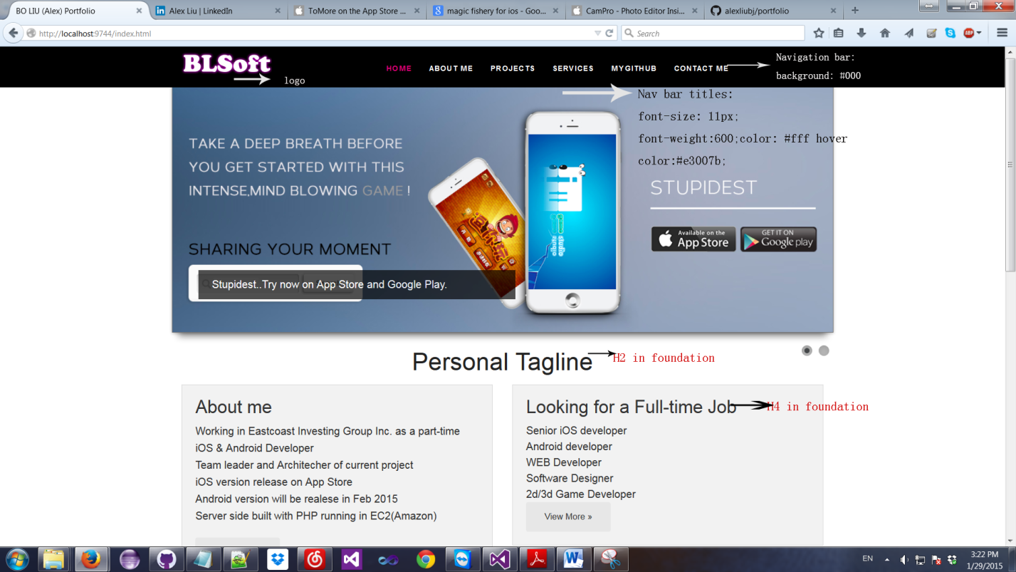

# Branding

Homepage

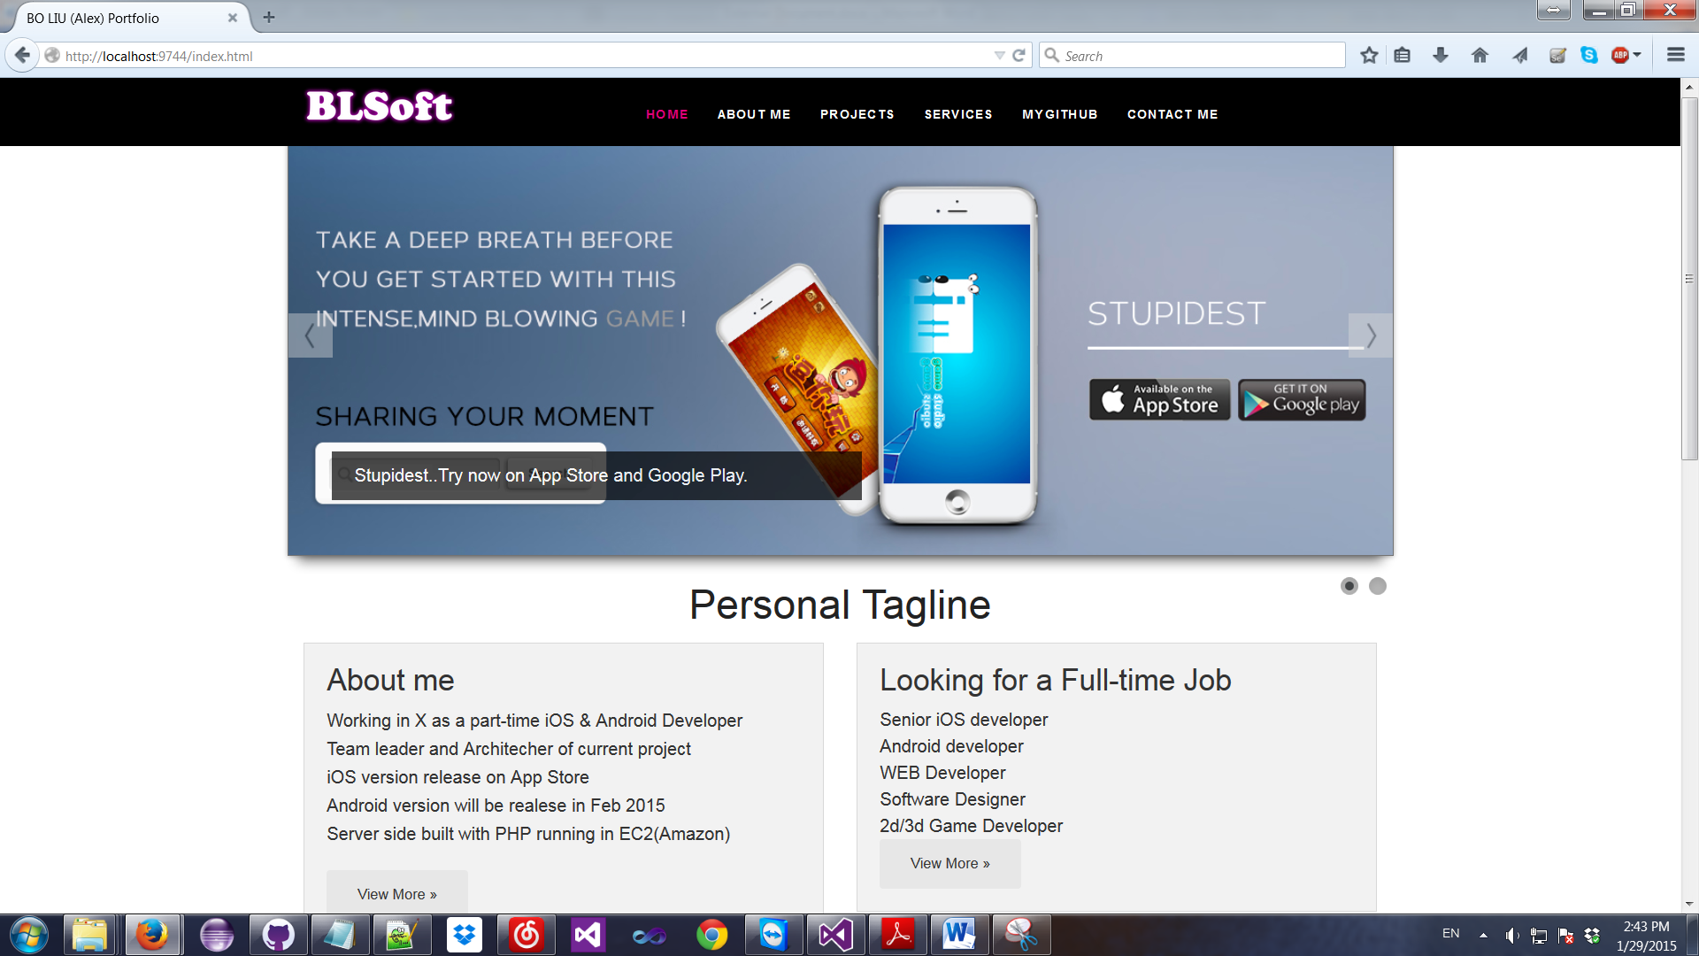

About me

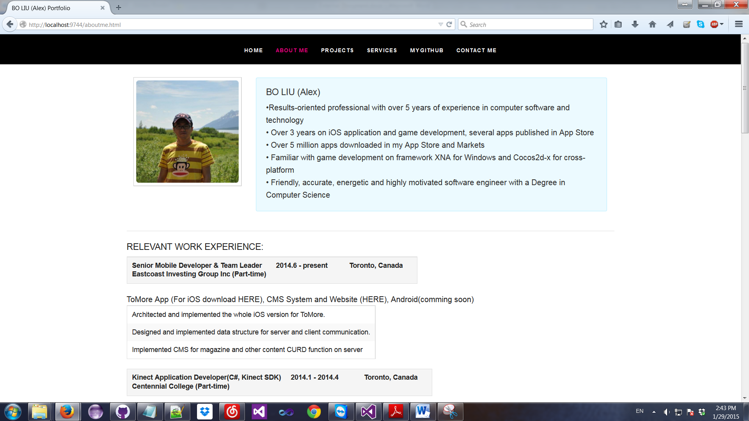

Projects

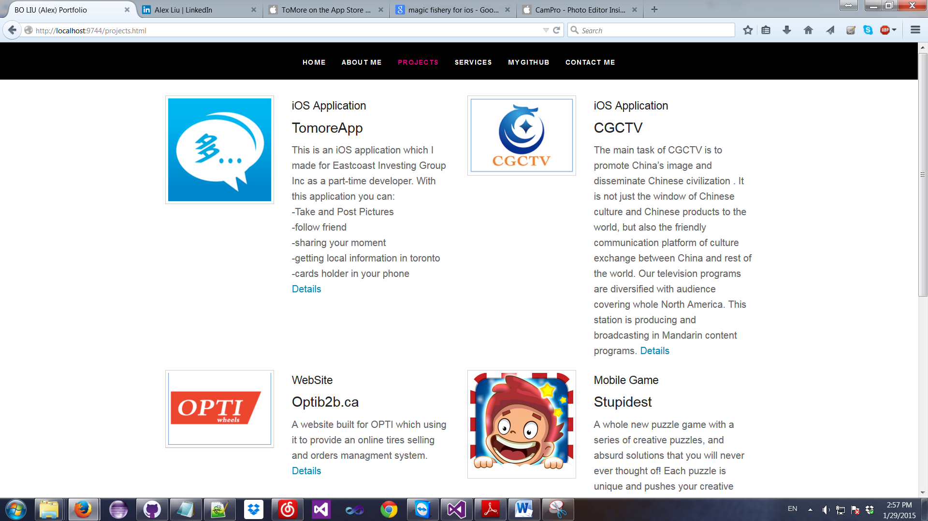

Services

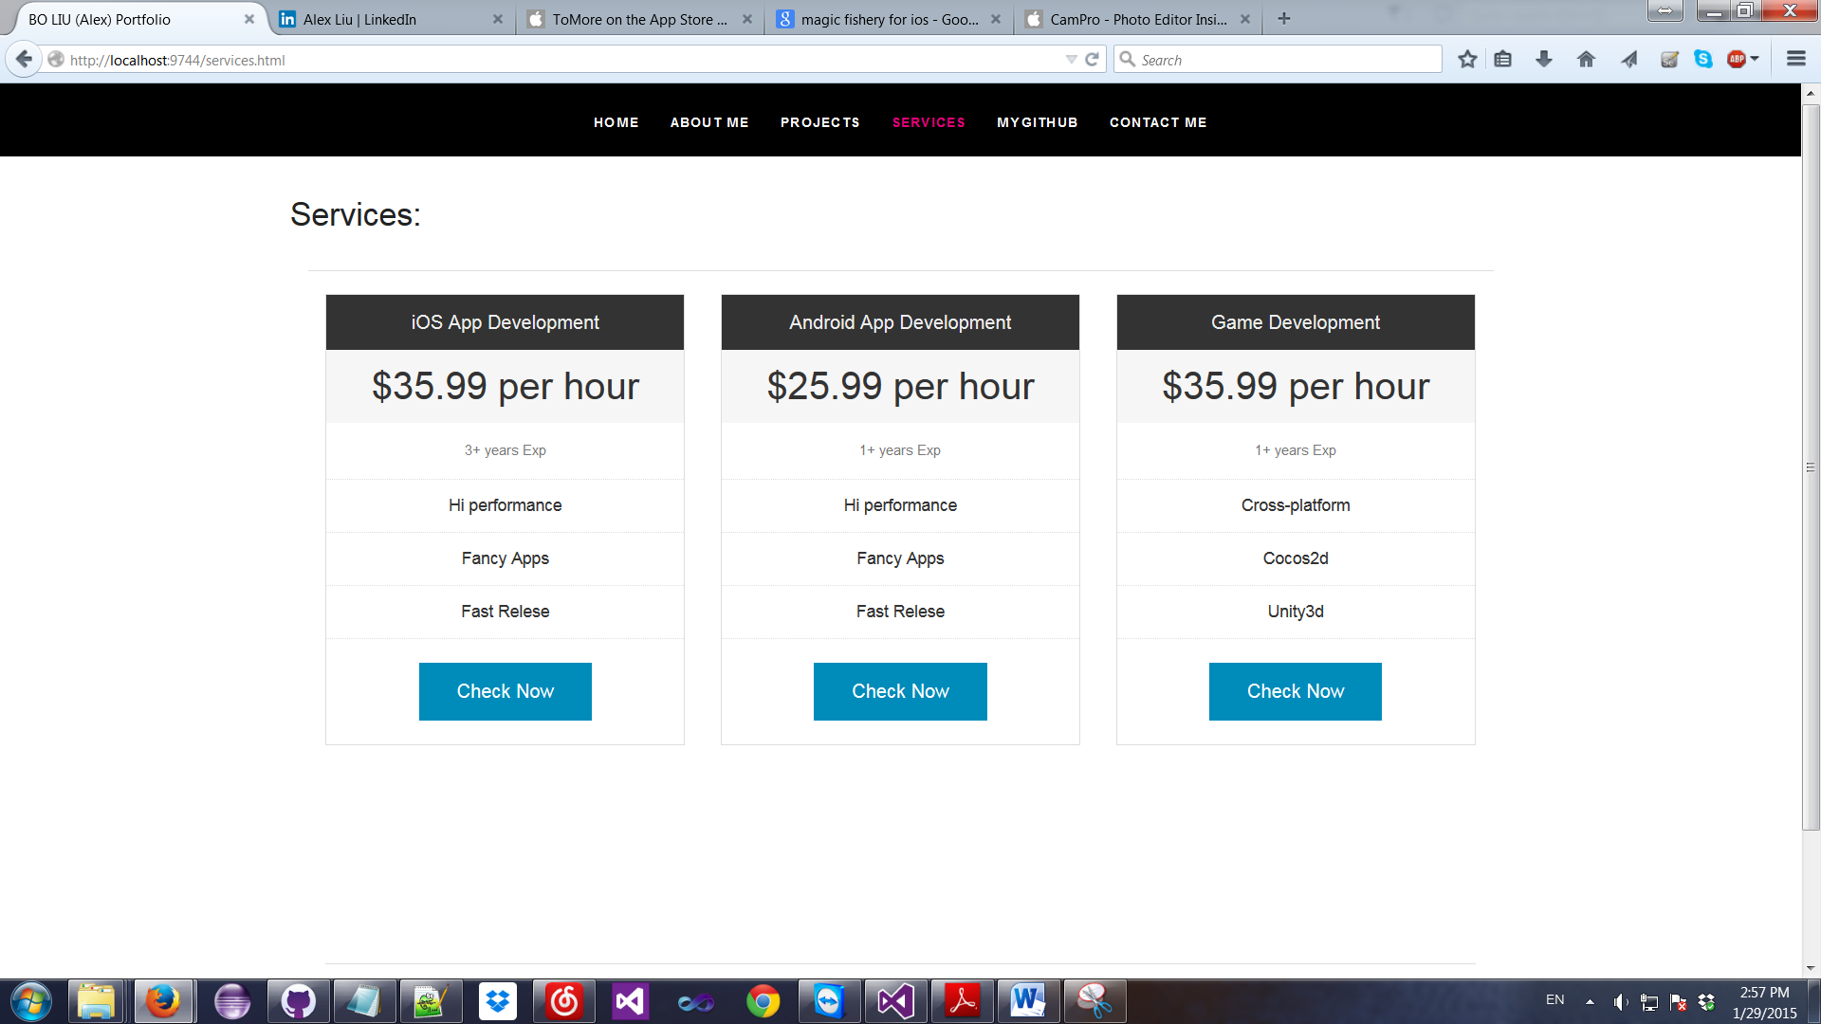

My Github

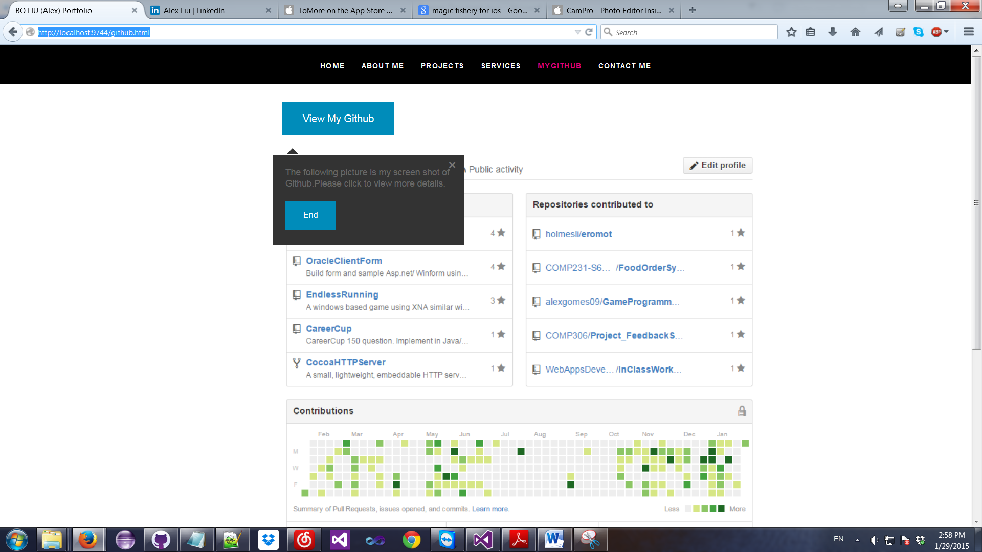

Contact me

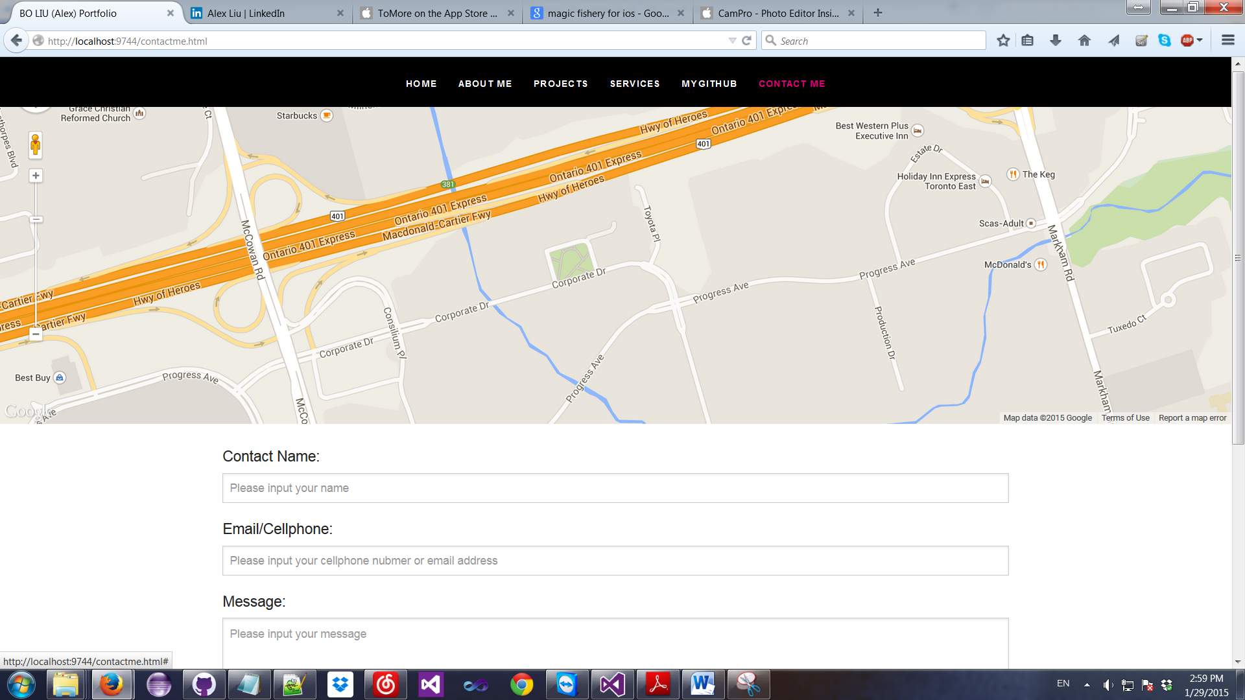

Logo

